**COURSE** **STRUCTURE**

1. Basic electronic principles
   * 1. Current, Voltage, Power
     2. Ohm’s law
2. Introduction **to** Electronic components
   * 1. Resistor
     2. Capacitor
     3. Inductor
     4. Diode
     5. Transistor
        1. BJT
        2. FET
     6. ICs
     7. Op-Amps
3. Basic circuits
   * 1. Using a Multimeter
     2. Making circuits- series, parallel
     3. Filters
        1. LPF
        2. HPF
        3. BPF
        4. NF
4. Diode Applications
   * 1. HWR
     2. FWR
     3. Clippers
     4. Clampers
5. Transistor
   * 1. Switch
     2. Amplifier
6. Make your own circuits
   1. LED Series and Parallel Connections
   2. Driving a Motor- http://www.circuitstoday.com/dc-motor-controller
   3. Water-level indicator- http://circuitdigest.com/electronic-circuits/water-level-indicator-alarm-circuit
   4. Burglar alarm- http://www.gadgetronicx.com/burglar-alarm-circuit-using-ic555/
   5. Temperature sensor- http://www.electroschematics.com/6255/temperature-alarm-2/
   6. Door open alarm- <http://www.eleccircuit.com/forget-door-alarm-circuit/>
   7. Obstacle Sensing Circuit or IR Sensor Circuit - http://www.electronicshub.org/ir-sensor/
   8. Travel mobile phone charger - http://www.electroschematics.com/4000/mobile-phone-travel-charger/
   9. Temperature controlled fan-

<http://www.electroschematics.com/9541/temperature-controlled-fan/>

* 1. Visitor counter -

<http://www.circuitsgallery.com/2015/11/visitor-counter-circuit.html>

* 1. Hospital room call bell circuit - <http://www.homemade-circuits.com/2016/01/hospital-room-call-bell-circuit.html>

1. **Basic electronic principles**

Current

Resistance

Voltage

Power

Ohm’s law

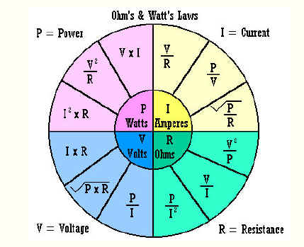

Electronic components

Resistor

Capacitor

Inductor

Diode

Transistor

* + 1. BJT
    2. FET
  1. ICs
  2. Op-Amps

1. Basic circuits
   1. Using a Multimeter
   2. Making circuits-

Series

Parallel

Filters

* + 1. LPF
    2. HPF
    3. BPF
    4. NF
  1. Diode Applications
     1. HWR
     2. FWR
     3. Clippers
     4. Clampers

Transistor

* + 1. Switch

<http://www.electronicshub.org/transistor-as-switch/>

* + 1. Amplifier